Chapter 05: Planar and Dual Graphs

Table of Contents

Kuratowski’s Two Graphs 2

Different Representations of a Planar Graph 4

Regions 5

Detecting Planarity 7

Geometric Dual 9

2-Isomorphism 11

Combinatorial Dual 12

Dual of a Subgraph 13

Dual of a Homeomorphic Graph 13

Rank and Nullity 15

Self-Duals 15

Thickness and Crossings 16

Detecting Planarity 16

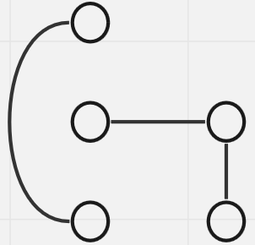

A **Planar Graph** is one which has at least one geometric representation for which none of the edges overlap. The graph above is planar, while the one below is non-planar.

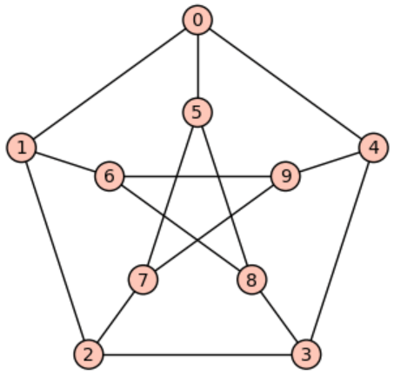

If a graph is planar, it is said to be **embedded** in the plane.

A real-life use case for planar graphs is to lay non-overlapping railway lines.

## Kuratowski’s Two Graphs

Theorem 5.1: The complete graph of five vertices, $K_{5}$, is non-planar.

Proof (by construction):

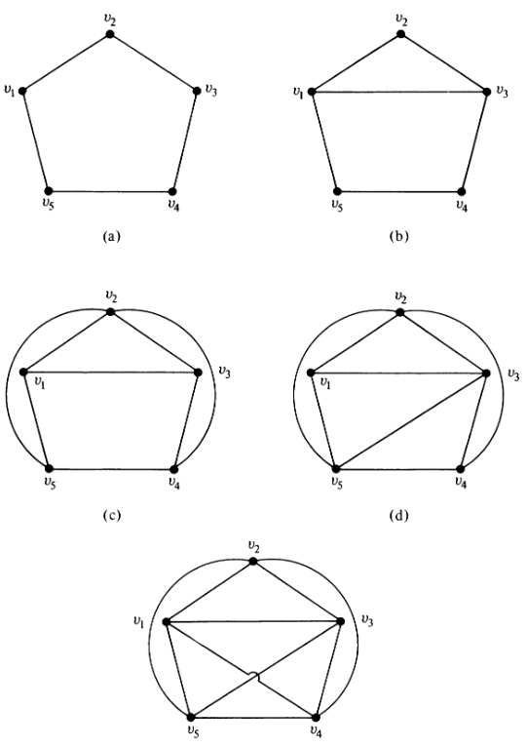

Theorem 5.2: Kuratowski’s second graph ($K_{3,3}$), is also non-planar.

Proof (by construction):

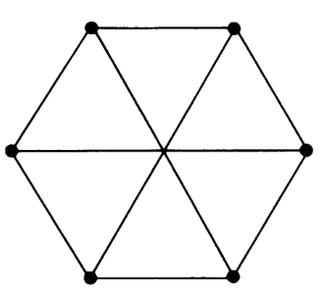

Properties of Kuratowski’s Graphs:

* Both are regular.
* Both are non-planar.
* Removing 1 edge from either graph makes the graph planar.
* $K_{5}$ has the smallest number of vertices required to make a non-planar graph.
* $K_{3,3}$ has the smallest number of edges required to make a non-planar graph.

## Different Representations of a Planar Graph

Theorem 5.3: Any simple planar graph can be embedded in a plane such that every edge is drawn as a straight line.

The proof for this theorem is being skipped.

Example:

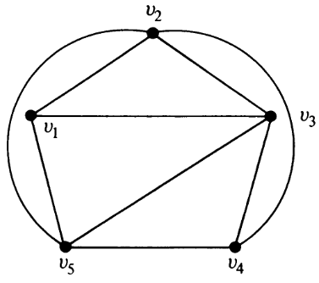 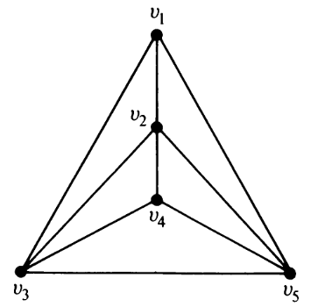

### Regions

Consider the edges a graph to be walls enclosing **regions**.

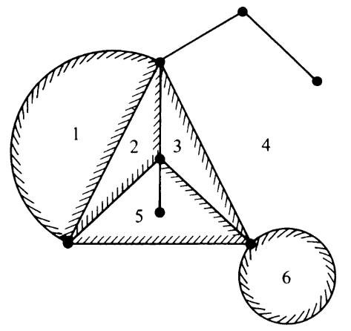

Each graph has one region that lies outside of the graph. For the graph above, this is region 4. This region is called the **infinite region**.

If we have two representations of the same planar graph, such as one which has only straight edges and another which has curved edges, the number of regions they have will be the same. However, the edges bounding the regions may vary. For example, in the two graphs below, the infinite region for the first graph is bounded by $v_{2}$, $v_{4}$ and $v_{5}$, while the infinite region for the second graph is bounded by $v_{1}$, $v_{3}$ and $v_{5}$.

 

Theorem 5.5: Any of the regions of a planar graph can be made the infinite region.

Theorem 5.6: A connected planar graph with $n$ vertices and $e$ edges has $f=e-n+2$ regions.

The proof for this is being skipped.

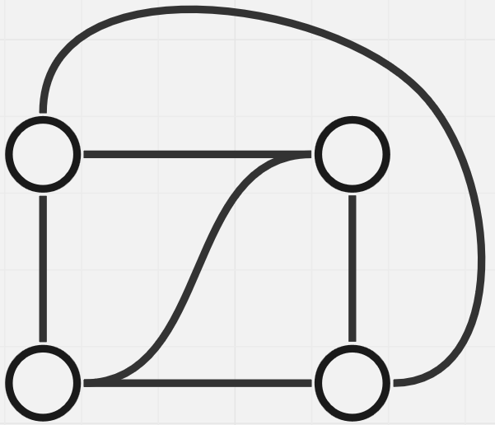

For the graph above, $n=4$, $e=6$ and $f=6-4+2=4$.

Each region needs at least $3$ edges to bound it. Each edge also contributes to exact $2$ regions. Thus:

$$2e≥3f$$

Using the equation from theorem 5.6, we can rewrite this equation as:

$$e≤3n-6$$

These two conditions are **necessary conditions** for planar graphs, i.e., a graph cannot be planar if either of these conditions are violated.

## Detecting Planarity

The straightforward way to check if a graph is planar is to just draw it. However, this method becomes too difficult for complicated graphs. Instead, we can use the following steps:

1. If the graph is disconnected, consider each component as a separate graph.
2. If the graph is separable, consider each block separately.
3. Remove all self-loops and parallel edges. These do not contribute to the planarity of the graph.
4. Remove all vertices with a degree of 2 since they do not change the planarity of the graph.

We must repeat the steps repeatedly until we cannot execute any of the steps anymore.

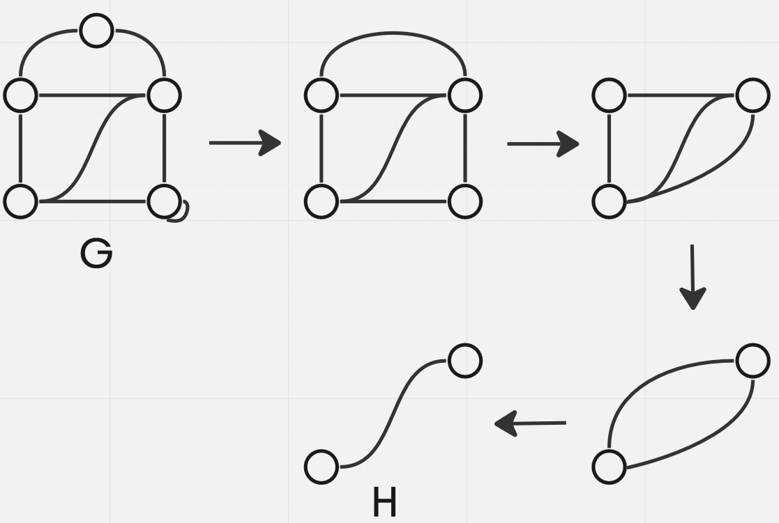

The graphs $G$ and $H$ are said to be **homeomorphic**.

Theorem 5.8: Graph $H$ is:

1. A single edge, or
2. A complete graph with 4 vertices, or
3. A non-separable simple graph with $n≥5$ and $e≥7$.

In the first two cases, $H$ is planar. In the third case, further checking is required.

Theorem 5.9: A necessary and sufficient condition for a graph $G$ to be planar is that $G$ does not contain either of the Kuratowski’s 2 graphs or any graph homeomorphic to either of them.

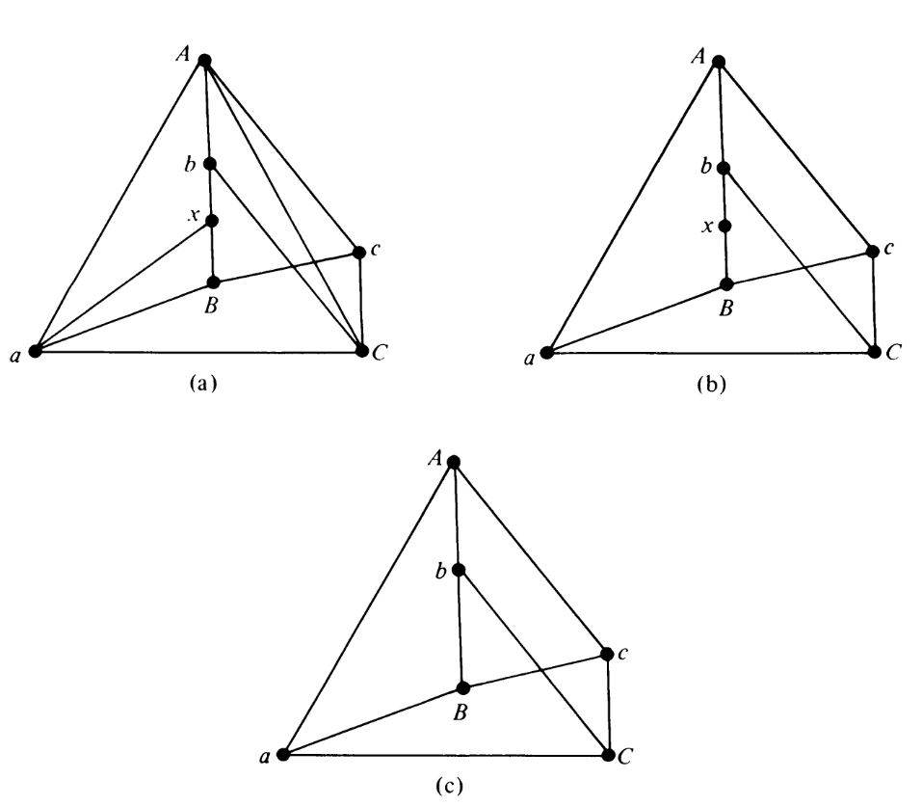

For the graphs above, graph $c$ is $K_{3,3}$ and graph $a$ is homeomorphic to graph $c$. Thus, none of the graphs are planar.

## Geometric Dual

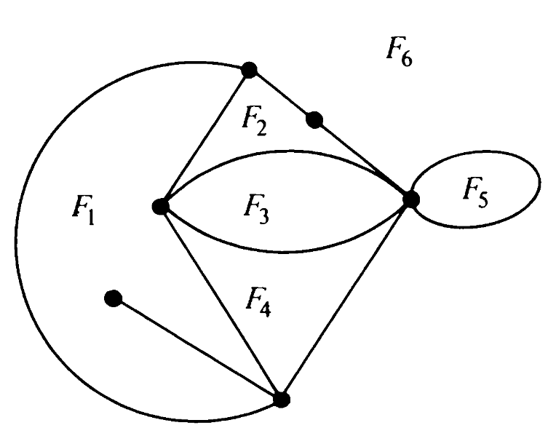

The graph above has six regions. If we consider **each region** to be a **vertex**, and connect the vertices that represent regions on either side of an **edge**, we end up with another graph, as shown below:

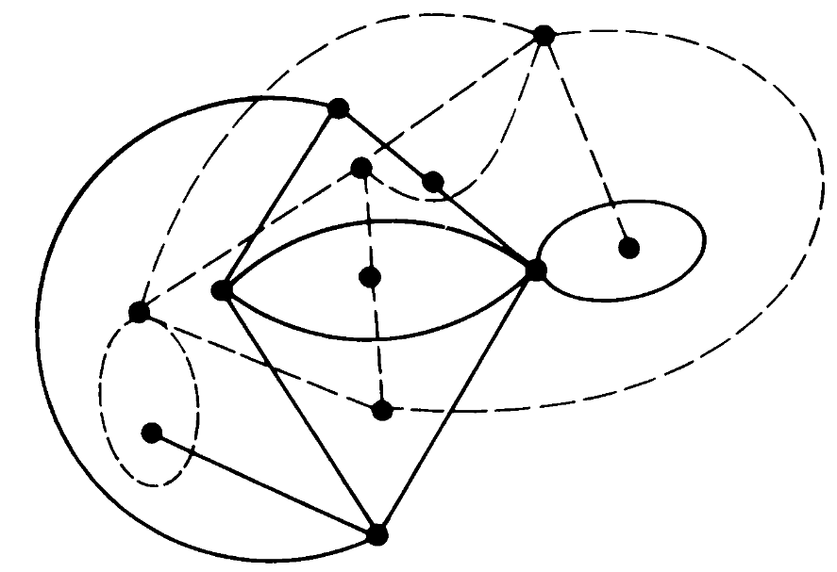

This is called a **dual graph**, denoted as $G^{*}$.

There are two important things to notice regarding the edges. Firstly, notice that there are **parallel edges** between $F_{1}$ and $F_{6}$. This is because there are two edges on the original graph that separate this region. Secondly, there is a **self-loop** at $F_{1}$. This is caused by the pendant vertex that protrudes into $F_{1}$ in the original graph. The pendent edge has $F_{1}$ on either side of it, so dragging an edge between the two regions on either side means drawing an edge from $F_{1}$ to $F_{1}$.

The dual graph has a **one-to-one correspondence** between **edges**, i.e., the number of edges is the same as in the original graph.

There are several important observations that can be made based on the original graph and its dual:

* A **pendant edge** causes a **self-loop**.
* Edges in **series** result in edges in **parallel**.
* Edges in **parallel** result in edges in **series** (consider $F_{2}→F_{3}→F_{4}$).
* The number of **edges incident** on a vertex in the dual graph is equal to the number of **edges bounding** the region in the original graph.
* Both the original and the dual graph are **planar**.

As can be seen, the properties of the original graph $G$ seem to become inverted in its dual graph, $G^{*}$. This also means $Dual Graph\left(G^{*}\right)=G$, meaning not only is $G^{*}$ the dual of $G$, but they are the duals of each other (💖).

We can also make observations regarding the number of vertices ($n$), the number of edges ($e$), the number of regions ($f$), the rank ($r$) and the nullity ($μ$) of the two graphs:

$n^{*}=f$

$f^{*}=n$

$e^{*}=e$

$r^{*}=μ$

$μ^{*}=r$

### 2-Isomorphism

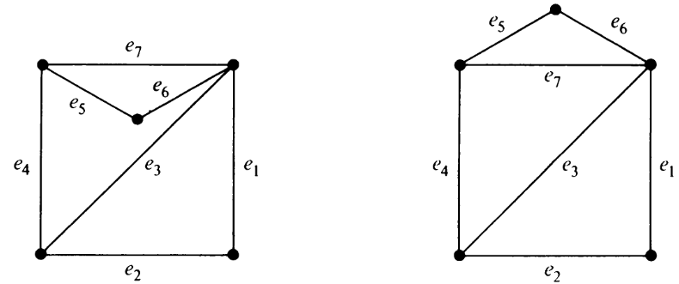

The two graphs above are **isomorphic** to each other. However, their dual graphs, shown below, are **not isomorphic**.

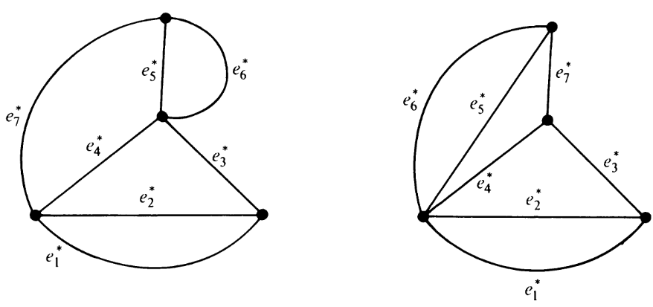

If we consider the cut-vertices of the graph on the left (the vertex between $e_{5}^{*}$, $e_{6}^{*}$, $e_{3}^{*}$ and $e_{4}^{*}$ and the one between $e_{7}^{*}$, $e_{4}^{*}$, $e_{2}^{*}$ and $e_{1}^{*}$) and split the graph into two components along them, we will find that rotating one of the components and joining them again will give us the graph on the right. Essentially, the two graphs are **2-isomorphic**.

Theorem 5.10: All duals of a planar graph $G$ are 2-isomorphic; and every graph 2-isomorphic to a dual of $G$ is also a dual of $G$.

The proof of this theorem is being skipped.

Note that this does not mean that dual graphs can never be isomorphic. It just means that even if they are not isomorphic, they are guaranteed to be 2-isomorphic.

## Combinatorial Dual

Theorem 5.11: A necessary and sufficient condition for two planar graphs, $G_{1}$ and $G_{2}$, to be duals of each other is as follows: There is a one-to-one correspondence between the edges in $G_{1}$ and the edges in $G_{2}$ such that the set of edges in $G_{1}$ forms a circuit if and only if the corresponding set in $G_{2}$ forms a cut-set.

Proof:

As a proof of this, we will consider a very simple graph, $C_{5}$, and its dual.

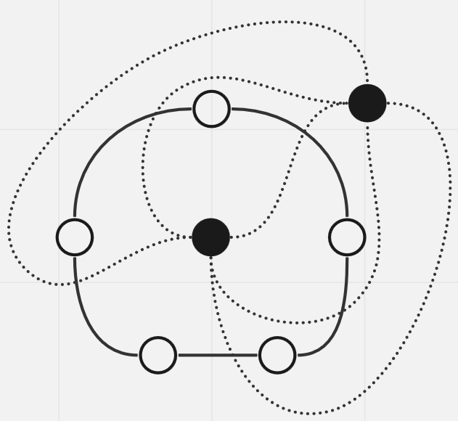

This is an easy example for our use case, because the entirety of $C_{5}$ is a circuit. The edges that correspond to this circuit in the dual are all 5 edges. An obviously if we remove all 5 edges, the dual will become disconnected. Thus, the edges create a cut-set in the dual.

### Dual of a Subgraph

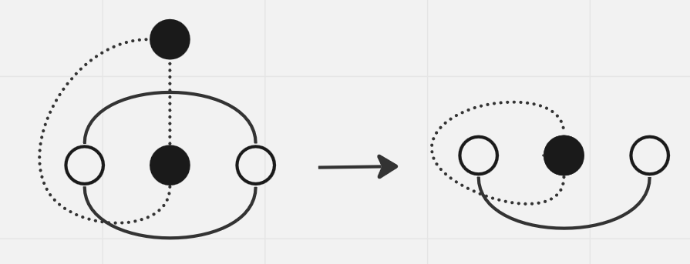

Suppose we have some graph $G$ with a dual graph $G^{*}$, from which we remove an edge $a$ in order to get a **subgraph**. The dual graph of the subgraph will be ${\left(G-a\right)}^{*}$.

If $a$ was at the boundary between two regions (the graph on the left), then removing $a$ will cause the two regions to become **merged** (the graph on the right). On the other hand, if $a$ is not on the boundary, it means that $a^{*}$ is a self-loop (the graph on the right). Removing $a$ will result in $a^{*}$ being removed, but the vertex for the self-loop will remain.

### Dual of a Homeomorphic Graph

Two important concepts in **homeomorphic graphs** are **series** and **parallel** edges. We previously discussed how these do not contribute to the planarity of the graph. As such, their effects on the dual of the graph are straightforward.

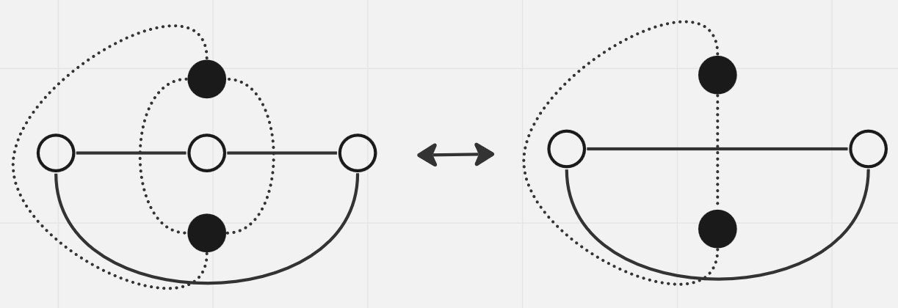

If there is a series edge in the original graph, then it causes a parallel edge in the dual. Removing the series edge means removing one of the parallel edges and vice versa.

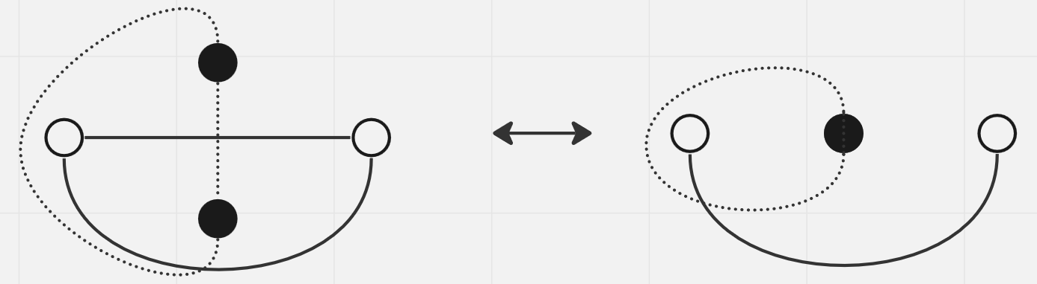

If there is a parallel edge in the original graph, then it causes a series edge in the dual. Removing one of the parallel edges means removing the series edge and vice versa. For the example above, it also resulted in the two vertices in the dual graph becoming merged since they were in the same region.

Theorem 5.12: A graph has a dual if and only if it is planar.

Proof: The proof for this lies in the fact that we cannot make dual graphs for the two Kuratowski’s graphs, $K_{3,3}$ and $K_{5}$.

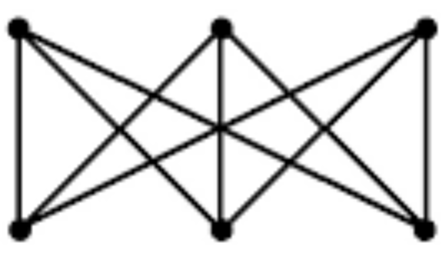

Suppose the dual of $K_{3,3}$ is $D$. The cut-sets of $K_{3,3}$ should correspond to circuits in $D$ (according to theorem 5.10). $K_{3,3}$ has no cut-sets of two edges, which means $D$ cannot have a circuit of two edges (i.e., parallel edges). On the flip side, every circuit in $K_{3,3}$ is of length four or six, meaning every cut-set of $D$ has at least four edges. Thus, the degree of every vertex in $D$ is at least four.

If the degree of every vertex in $D$ is at least four and there are five vertices in $D$ (corresponding to the five regions in $K_{3,3}$), then there should be a total degree of $20$, corresponding to $10$ edges. $K_{3,3}$ however, has $9$ edges, which means $e≠e^{*}$. Thus, $D$ cannot exist.

A similar situation can be shown for $K_{5}$.

### Rank and Nullity

Two planar graphs $G$ and $G^{*}$ are said to be duals of each other if there is a one-to-one correspondence between the edges of $G$ and $G^{*}$ such that if $g$ is a subgraph of $G$ and $h$ is the corresponding subgraph of $G^{*}$, then

Rank of $\left(G^{*}-h\right)=$ Rank of $G^{*}-$ nullity of $g$

### Self-Duals

If a planar graph $G$ is **isomorphic** to its own dual, it is called a **self-dual graph**. An easy example of a self-dual graph is $K_{4}$.

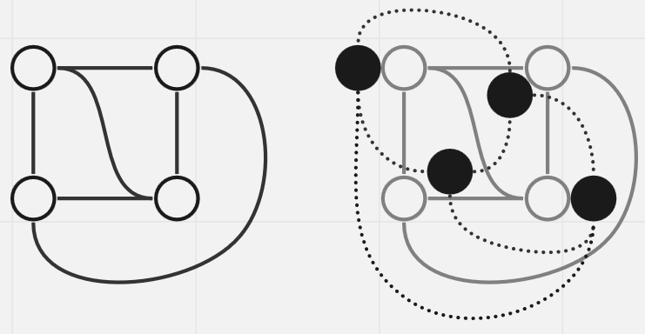

## Thickness and Crossings

For graphs that are **non-planar**, the **number of planes** required to embed the graph is called the **thickness** of the graph.

If we force ourselves to embed a non-planar graph on a plane, the **number of intersections** required is called the **crossings** of the graph.

## Detecting Planarity

In conclusion, for a given graph, to detect whether it is planar or not we must follow these steps:

1. Use the Euclidean formulae ( $e≥\frac{3}{2}f$ and $e≤3n-6$). If either condition fails, the graph is non-planar.
2. If step one is passed, try to create a homeomorphic graph by using the steps outlined previously (removing self-loops, parallel edges and vertices with degree 2). If this results in a graph that is a simple edge or a complete graph with 4 vertices, the graph is planar.
3. If step 2 results in a non-separable simple graph with $n≥5$ and $e≥7$, try creating a dual graph. If a dual can be created, then the graph is planar.